**Project Report of iRelovution: A Data-Driven Exploration of Apple iPhone’s Impact in India**

**Team Coordinator:** Jayasurya R

**Team Members:**

Gopalakrishnan P

Sanjay S

Sriram L

**Team ID:** NM2023TMID15639

**Mentor:** Mr. N.R. Thirumal, M.Sc., B.Ed., M.Phil.

**College:** Government Arts College, Dharmapuri - 05

**Introduction:**

In an era marked by technological revolutions, the advent of smartphones has played a pivotal role in reshaping consumer behavior and market dynamics. One such transformative force is the iPhone, and its journey in the vibrant and diverse landscape of India is the focal point of our project – "iRevolution: A Data-Driven Exploration of Apple iPhone’s Impact in India (Team ID: NM2023TMID15639).

**Overview of My Project:**

The project, "iRevolution," employs Tableau to meticulously analyze and visualize the transformative journey of iPhones in the Indian market. Through insightful data representations, the project aims to provide a comprehensive understanding of adoption patterns, market trends, and the overall impact of Apple's flagship product in India.

**Purpose:**

The purpose of "iRevolution" is to unravel the complexities of the iPhone's evolution in India through a data-driven lens. By examining sales trends, user preferences, and market dynamics, the project seeks to offer valuable insights for stakeholders, enthusiasts, and market analysts.

**Problem Definition and Design Thinking:**

The project addresses the challenge of comprehending the multifaceted factors influencing iPhone adoption in a diverse market like India. Employing design thinking principles, the exploration involves user-centric perspectives, market demands, and challenges posed by competitors to uncover patterns contributing to the iPhone's growth.

**Empathy Map:**

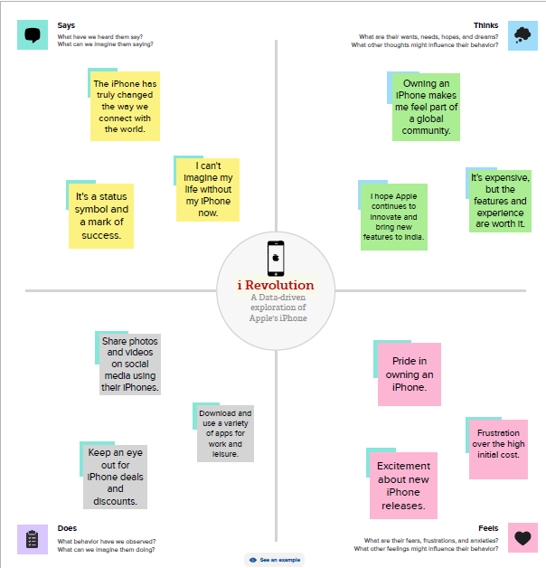

**Brainstorming Map:**

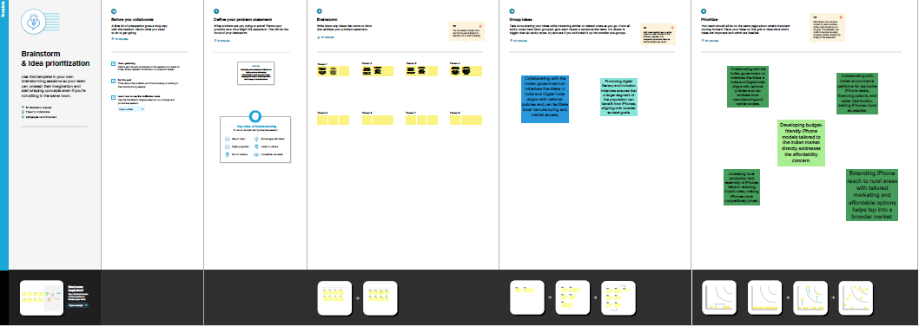

**Result:**

Tableau visualizations within the project unveil a timeline of iPhone launches, regional sales variations, and the impact of pricing strategies on consumer behavior. Insights into the success of specific models, user demographics, and the influence of ecosystem integration provide a comprehensive understanding of the iPhone's journey in India.

**Advantages & Disadvantages of the Proposed Solution:**

Advantages:

- In-depth insights into market trends.

- Identification of factors driving iPhone adoption.

- Enhanced understanding of consumer preferences.

- Data-driven decision-making for Apple and stakeholders.

Disadvantages:

- Limited by available data.

- Potential oversights in qualitative aspects not captured by quantitative data alone.

**Conclusion:**

In conclusion, "iRevolution" emphasizes the pivotal role of data in unraveling the narrative of the iPhone's journey in India. It underscores the importance of data-driven approaches in understanding market dynamics and consumer behavior, highlighting the transformative impact of iPhones.

**Future Scope:**

The future scope of "iRevolution" includes:

- Integration of real-time data for ongoing analysis.

- Collaboration with Apple for more granular insights.

- Expansion of analysis to include competitor comparisons.

**Appendix:**

The appendix contains detailed data sources, snapshots of Tableau workbooks, and any supplementary materials supporting the project's findings and visualizations. This section ensures transparency and allows stakeholders to delve deeper into the methodology and data used in the project.

**Gratitude:**

This project was a collective endeavor, and we are thankful for the collaborative spirit that permeated every stage. Each contribution, big or small, played a role in shaping "iRevolution." Thank you for being an integral part of this journey.